Safeguarding & Child Protection Policy

Health and Social Care Standards (My Support, My Life):

- Standard 3.14: "I have confidence in people because they are trained, competent and skilled, are able to reflect on their practice and follow their professional and organisational codes."
- Standard 3.20: "I am protected from harm, neglect, abuse, bullying and exploitation by people who have a clear understanding of their responsibilities."
- Standard 3.21: "I am protected from harm because people are alert and respond to signs of significant deterioration in my health and wellbeing, that I may be unhappy or may be at risk of harm."
- Standard 3.22: "I am listened to and taken seriously if I have a concern about the protection and safety of myself or others, with appropriate assessments and referrals made."

Associated Legislation, Guidance & Internal Documents
This policy operates in direct alignment with national frameworks and internal operational guidance:
Statutory & National Frameworks:
- National Guidance for Child Protection in Scotland (2021)
- The Promise (2020) (Independent Care Review)
- Getting It Right For Every Child (GIRFEC) & SHANARRI Wellbeing Indicators
- United Nations Convention on the Rights of the Child (UNCRC)
- Safer Recruitment Through Better Recruitment (2016) (Care Inspectorate)
- NSPCC Child Protection Training & Safeguarding Standards
Related Stramash Operational Documents:
- Stramash Guidelines on the Use of Photography and Video
- Stramash Whistleblowing Policy

1. Ethos, Vision & Policy Statement
Stramash is committed to ensuring the safety, welfare, and holistic wellbeing of every child in our care. We recognise that the welfare of the child is paramount. We have a clear duty of care to implement robust, effective procedures for safeguarding all children in accordance with Scottish Government national guidance, Care Inspectorate regulations, and the Health and Social Care Standards.

Our approach to safeguarding and child protection is built upon three core frameworks:

- The Promise (2020): We recognise that true safeguarding relies on relational safety—building warm, trusting, and consistent relationships where children feel secure, heard, and valued. We support families early to prevent crises, respect sibling bonds, and ensure non-stigmatising practice.
- Getting It Right For Every Child (GIRFEC): We keep the child firmly at the centre, utilising the SHANARRI wellbeing indicators to identify and respond to needs early.
- United Nations Convention on the Rights of the Child (UNCRC): We champion children's rights, ensuring children are protected from all forms of abuse, neglect, and exploitation while actively participating in decisions that affect them.

This policy applies to all staff, volunteers, students, visitors, and board members across all Stramash settings and training events.

2. PART A: Everyday Safeguarding (Prevention & Promoting Wellbeing)
Safeguarding is the proactive, daily work we do to create a safe, nurturing, and empowering environment where risks are minimised, and wellbeing is actively promoted.

A. Safer Recruitment & Workforce Verification
To prevent unsuitable individuals from working with children, Stramash strictly adheres to the Care Inspectorate’s Safer Recruitment Through Better Recruitment (2016) guidance:

- No adult will work or volunteer on site without a completed, satisfactory Protection of Vulnerable Groups (PVG) scheme check for regulated work with children.
- All appointments require verified professional references, qualifications checks, and structured interviews exploring candidate values and safeguarding awareness.
- Stramash maintains a zero-tolerance approach to inappropriate adult behaviour. Any concern, observation, or allegation regarding a staff member, volunteer, or visitor breaching child safety boundaries or causing harm must be reported immediately to the Nursery Head (DCPL) or directly to the co-CEO’s. Staff are fully supported to raise concerns under the Stramash Whistleblowing Policy. Concerns regarding leadership will be reported directly to the Head of Nurseries or Head of Operations and Finance. If there is a concern regarding them, that should be reported directly to the Board of Directors and the Care Inspectorate.

B. Mandatory NSPCC Training, Inductions & DCPL Roles
- Stramash operates a strict safeguarding entry gate. No member of staff, student, or volunteer is permitted to work with or care for children until they have successfully completed their NSPCC Child Protection Training. Completion is verified and logged prior to any direct practice on site.
- Every Stramash site has a minimum of two trained Designated Child Protection Leads (DCPLs)—consisting of the Nursery Head and Practice Leads—who have completed advanced NSPCC DCPL training.
- All new staff undergo a comprehensive safeguarding induction covering "soft signs" of concern, internal recording protocols, and reporting pathways.
- Annual child protection refresher training is mandatory for all staff. Child protection is a standing agenda item at all weekly site team meetings and monthly senior leadership meetings to support continuous reflection.

C. Supervision, Ratios & Informed Risk Assessment
Staff ensure active supervision matching or exceeding statutory Care Inspectorate ratios at all times. Stramash balances adventurous outdoor learning with rigorous safety management through three levels of risk assessment:
- A series of site-applicable, written risk assessments inform staff on managing identified risks and implementing control measures to prevent harm.
- Stramash recognises its unique role in promoting adventurous, risky play across all weather conditions in rural outdoor environments. Stramash staff are trained and regularly monitored to ensure they are confident and competent in dynamically assessing play, weather shifts, and environmental risks in real time.
- We take active steps to prevent harm and create an environment that minimises risks to children that may cause detriment or serious injury, without removing beneficial developmental challenge.
- Individual personal plans, care protocols, and medical/dietary risk assessments are maintained for every child to deliver responsive, tailored care.

D. Digital Safety & Recording Devices
Staff must only use setting-approved devices to document children’s learning profiles in line with the Stramash Photographs and Recording Devices Policy. At no point will imagery be captured that compromises a child’s dignity, privacy, or safety.

3. PART B: Child Protection (Responding to Abuse, Harm & Neglect)
Child protection is the multi-agency process of taking action to protect individual children who are suffering, or are at risk of suffering, significant harm.

A. Definitions & Indicators of Harm
In accordance with the National Guidance for Child Protection in Scotland (2021), staff are trained to recognise indicators across four main categories of maltreatment:

- Physical Abuse: Hitting, shaking, throwing, burning, scalding, or physical harm.
- Emotional Abuse: Persistent emotional ill-treatment, severe overprotection, ridiculing, or seeing/hearing domestic abuse.
- Sexual Abuse & Exploitation: Involving a child in sexual activity or non-contact activities (such as indecent images or inappropriate language).
- Neglect: Persistent failure to meet a child’s basic physical, emotional, or psychological needs (food, clothing, warmth, medical care, or nurturance).
- "Soft Signs" of Concern: Uncharacteristic changes in behaviour, emotional withdrawal, regression, extreme clinginess, or subtle shifts in play themes.

B. Emergency Protocol & Internal Reporting
EMERGENCY RESPONSE (IMMEDIATE DANGER): If a child is in immediate physical danger, requires urgent medical attention, or a crime is taking place, staff must call 999 (Police / Ambulance) without delay. Do not wait for internal discussions or form submissions before securing immediate safety.
Once safety is secured, or for non-emergency concerns, follow this internal reporting process:

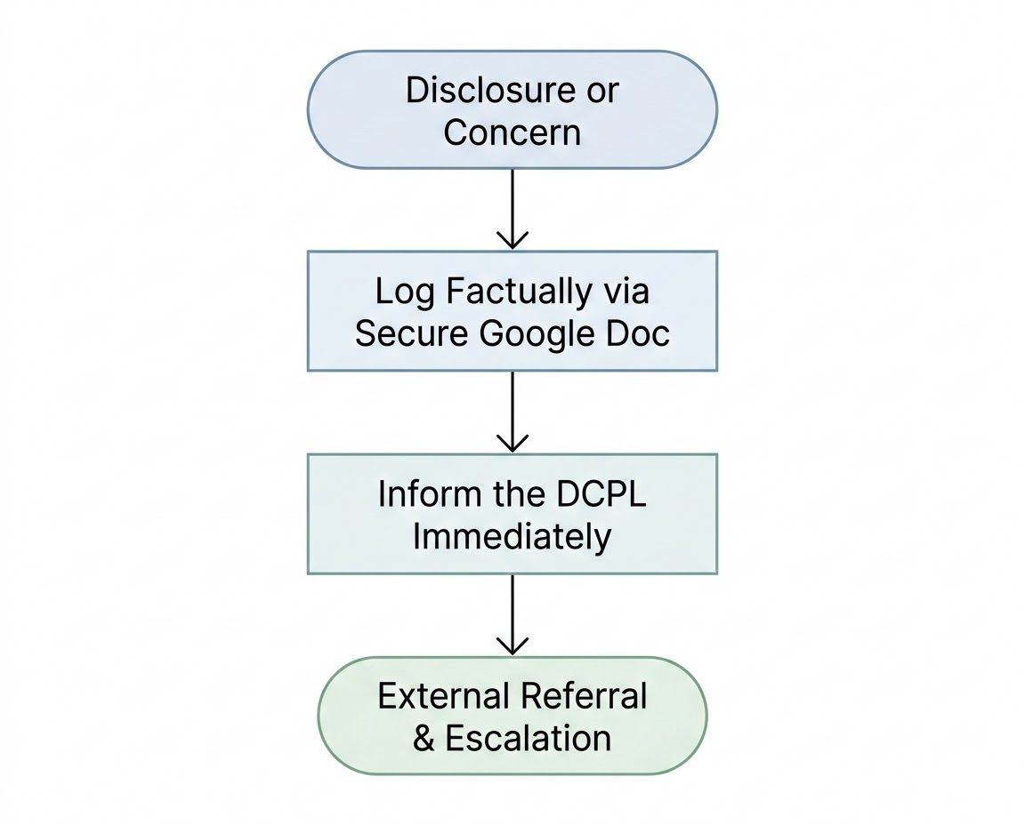

Flowchart Summary & Emergency Protocol:

Establish Facts: Listen calmly, reassure the child, do not ask leading questions, and do not attempt to conduct an independent investigation.

Internal Logging & DCPL Escalation: Log factual observations immediately via the secure Stramash Child Protection Google Doc and report directly to the site DCPL (Nursery Head or Practice Lead).

External Referrals: The DCPL will determine whether to contact local authority Children and Families Social Work (e.g., completing a Highland Council Form 1) and submit required notifications to the Care Inspectorate

C. Staff Guidance During a Disclosure
- DO: Listen attentively and calmly. Reassure the child that they were right to tell you.
- NEVER PROMISE SECRETS: Gently explain to the child that you must pass this information to the DCPL to ensure they stay safe.
- AVOID LEADING QUESTIONS: Ask open, non-leading prompts only (e.g., "Tell me what happened" or "Is there anything else you want to tell me?").
- DO NOT INVESTIGATE: Staff must not attempt to carry out their own investigation or confront any alleged perpetrator.
- RECORD FACTUALLY: Write down the exact words used by the child, date, time, location, and factual observations on the internal Google Doc immediately following the conversation.
- STRICT CONFIDENTIALITY & NO GOSSIPING: Information regarding a disclosure or child protection concern is strictly confidential. Staff must never discuss disclosures or child protection concerns with other colleagues, parents, or outside parties. Information must only be shared on a strict "need-to-know" basis with designated leads (DCPLs/Co-CEOs) and investigating authorities.
- MAINTAIN A CONSISTENT RELATIONSHIP: Continue to treat the child with warmth, normality, and care. Children need to know they have not been rejected or caused trouble by trusting an adult with a disclosure.
- STAFF DEBRIEF & EMOTIONAL SUPPORT: Receiving a disclosure of abuse can be emotionally challenging and distressing. Any staff member who receives a disclosure will be offered immediate, confidential debriefing and ongoing emotional support from their DCPL (Nursery Head or Practice Lead), Co-CEOs, or via employee support services.

D. Recording, Digital Storage & Local Authority Integration
- Internal records of concern are captured via a secure internal Google Docs and stored directly within restricted, encrypted folders on the Stramash Google Drive. Access is strictly restricted to designated DCPLs and senior leadership.
- Records must contain objective facts, exact statements made by the child, and observations. Assumptions or speculative opinions must not be recorded.
- Where required by the relevant council (e.g., Highland Council Form 1), the DCPL will complete and submit the required local authority documentation alongside internal Google Drive logs.
- All concerns, discussions, and external consultations are maintained within the child's secure Child Protection Chronology.
- If a child moves to another ELC or primary school, child protection chronologies are securely passed directly to the receiving Named Person / Lead Professional in line with national transfer guidance.

E. Multi-Agency Working (IRD & CPPM)
Stramash staff actively participate in statutory multi-agency processes led by local authority Social Work, Police, and Health teams:

- Inter-Agency Referral Discussions (IRD): DCPLs provide requested qualitative evidence regarding the child’s presentation and attendance.
- Child Protection Planning Meetings (CPPM): Designated leads attend CPPMs to contribute to collective risk assessments and help formulate and deliver Child Protection Plans.

4. Roles & Responsibilities Framework
Stramash provides clear criteria and expectations for all staff, volunteers, and students to ensure a shared understanding of safeguarding responsibilities across every level of the organisation.

Co-CEOs (Head of Nurseries & Head of Operations and Finance)
- Oversee the implementation of Care Inspectorate Safer Recruitment procedures across the organisation.
- Act as the first point of contact for any safeguarding concerns or allegations raised regarding anyone in a Nursery Head position.
- Lead investigations into allegations against leadership/staff and determine appropriate action in line with organisational disciplinary and whistleblowing procedures.
- Ensure organisational policy, local protocols, and guidance remain up-to-date and compliant with Scottish national guidance.
- Assist Nursery Heads and Practice Leads in providing information, guidance, and training in relation to good practice as required.

Nursery Heads & Practice Leads (Designated Child Protection Leads - DCPLs)
- Ensure all site staff and volunteers understand and follow child protection procedures and relevant Local Authority guidelines (e.g., Highland, Moray, Argyll & Bute).
- Act as the site DCPLs and primary points of contact for any child protection disclosures, concerns, or allegations.
- Implement safer recruitment protocols for site staff, modern apprentices, and volunteers.
- Review internal Google Doc logs, update child chronologies, complete required local council forms, and make formal referrals to Local Authority Social Work, Police Scotland, and the Care Inspectorate as required.

Practitioners & Apprentices
- Must complete NSPCC Child Protection Training prior to working directly with or supervising children.
- Conduct all outdoor sessions in accordance with Stramash safeguarding and risk-benefit guidance.
- Immediately report any incidents, "soft signs," or welfare concerns regarding children or vulnerable adults to a site DCPL (Nursery Head or Practice Lead).
- Log factual observations immediately via the secure Stramash Child Protection Google Doc.
- Practice Leads assist Nursery Heads in monitoring daily staff compliance with safeguarding policies.

Bank Staff, Students & Volunteers
- Must complete NSPCC Child Protection Training prior to working on site or supporting sessions with children.
- Work alongside permanent Stramash staff to promote a safe, nurturing, and child-centred outdoor environment.
- Promptly report any observed incidents, disclosures, or concerns regarding child welfare directly to a site DCPL (Nursery Head or Practice Lead).
- Implement relevant immediate response protocols (e.g., calling 999 in an emergency) under the guidance of site leads.

Young Workers & Modern Apprentices (Aged 16–17)
Stramash recognises that 16- and 17-year-old Modern Apprentices hold a unique dual position within our settings:
- Under the National Guidance for Child Protection in Scotland (2021), individuals under the age of 18 are legally defined as children. Stramash owes a direct duty of care to safeguard young workers from abuse, harm, bullying, or workplace exploitation. Any welfare concern or allegation involving a 16- or 17-year-old apprentice will be handled under our child protection reporting procedures, in coordination with relevant local protection partners and modern apprenticeship providers.
- As employees and trainees, apprentices are supported to develop full professional practice and hold a duty of care towards the children in the setting:
  - Must successfully complete NSPCC Child Protection Training prior to working on site with children.
  - Once trained and assessed as competent through their site induction and personal development plan, apprentices are trusted and supported to carry out day-to-day care routines (such as personal care/toileting and facilitating small group outdoor play).
  - Apprentices receive ongoing mentoring and oversight from their Nursery Head and Practice Lead to ensure they feel confident in their practice, risk-benefit management, and personal boundaries.
  - Must immediately report any child welfare concerns or "soft signs" directly to a site DCPL (Nursery Head or Practice Lead) via the secure internal Google Doc.

5. Supporting Young Workers & Vulnerable Adults
Stramash recognises a duty of care to identify and respond to signs of harm, exploitation, or abuse affecting young workers, trainees, or modern apprentices employed by or placed with Stramash, coordinating support with relevant local protection partners.

APPENDICES: LOCALITY REFERRAL GUIDES
When an external report or consultation is required, the site DCPL will utilise the specific Local Authority process below alongside our internal Google Drive records.

APPENDIX 1:

Child Protection Statement

Stramash believes that it is always unacceptable for a child or young person to experience abuse of any kind and recognises its responsibility to safeguard the welfare of all children and young people, by a commitment to practice which protects them.
We recognise that:
• the welfare of the child/young person is paramount
• all children, regardless of age, disability, gender, racial heritage, religious belief,
sexual orientation or identity, have the right to equal protection from all types of
harm or abuse
• working in partnership with children, young people, their parents, carers and other
agencies is essential in promoting young people’s welfare.
We will seek to safeguard children and young people by:
• valuing them, listening to and respecting them
• adopting child protection guidelines through procedures and a code of conduct
for staff and volunteers
• recruiting staff and volunteers safely, ensuring all necessary checks are made
• sharing information about child protection and good practice with children,
parents, staff and volunteers
• sharing information about concerns with agencies who need to know, and
involving parents and children appropriately
• providing effective management for staff and volunteers through supervision,
support and training.
We are also committed to reviewing our policies and good practice annually.
Stramash Elgin:
IF YOU HAVE A CHILD PROTECTION CONCERN PLEASE SPEAK TO A MEMBER OF STAFF DIRECTLY OR CONTACT:

Graeme Thompson - Elgin Nursery Co-Head (Graeme@stramash.org.uk) (Designated Child Protection Lead) (07961900801)
Joanne Moore -Elgin Nursery Co-Head (Joanne@stramash.org.uk) (Designated Child Protection Lead) (07961900802)
Or
Rebekka Winkler - Practice Lead (Rebekka@stramash.org.uk) (Designated Child Protection Lead)
Kerry Nicolson - Practice Lead (Kerry@stramash.org.uk) (Designated Child Protection Lead)

Alternatively, you can contact Elgin Council Social Services on:
01343 554370 or out of hours please call 03457 565 656.
or
call Police Scotland on 101.

Stramash Fort William:
IF YOU HAVE A CHILD PROTECTION CONCERN PLEASE SPEAK TO A MEMBER OF STAFF DIRECTLY OR CONTACT:
Lyndsay Boyd, Nursery Head at lyndsay@stramash.org.uk or on 07947 889197

Or alternatively speaking to Bianca Lyall or Ellis Davren at bianca@stramash.org.uk or ellis@stramash.org.uk or on 07947 889197

If urgent and out of hours please contact
Highland Council Social Services on:
Telephone: 01349 886 606 or if out of hours please call 0845 601 4813
or
Police Scotland on 101

Stramash Oban:
IF YOU HAVE A CHILD PROTECTION CONCERN PLEASE SPEAK TO A MEMBER OF STAFF DIRECTLY OR CONTACT:
Adam Gilmovich - Nursery Head (adam@stramash.org.uk) (07947479106 or 07944994060)
Or
Cath Davey -Practice Lead (cath@stramash.org.uk) (01631 566080)
Sam Gill - Practice Lead (sammi@stramash.org.uk) (01631 566080)

Alternatively, you can contact Argyll & Bute’s Social Work department to report concerns:
during office hours - 01546 605517 or use the online enquiry form
(https://www.argyll-bute.gov.uk/forms/social-work-enquiry-form)
evenings and weekends - 01631 566491 or 01631 569712
You can also call Police Scotland on 101.
Stramash Tornagrain:
IF YOU HAVE A CHILD PROTECTION CONCERN PLEASE SPEAK TO A MEMBER OF STAFF DIRECTLY OR CONTACT:

Stephanie Johnston - Tornagrain Nursery Head (Designated Child Protection Lead) (stephanie@stramash.org.uk) (07947 479103)
Claire Macpherson - Practice Lead (Designated Child Protection Lead) - (claire@stramash.org.uk) (07961 900807)
Maisie Mackenzie - Practice Lead (Designated Child Protection Lead) - (maisie@stramash.org.uk) (07958 759792)

Alternatively, you can contact Highland Council Social Services on:
01667 422880 or out of hours please call 0808 175 3646.
or
call Police Scotland on 101.

