Absent Child Policy

Health and Social Care Standards:
1.2 My human rights are protected and promoted and I experience no discrimination.
3.20 I am protected from harm, neglect, abuse, bullying and exploitation by people who have a clear understanding of their responsibilities.
3.25 I am helped to feel safe and secure in my local community.
5.17 My environment is secure and safe.

Stramash, as an organisation, acknowledges that attendance in nursery settings is not a statutory requirement however, in order for a child to have a positive and settled nursery experience, Stramash recommends regular attendance.

Where a child is absent that day, parents/carers are requested to let the nursery know either by calling or texting the site mobile or via the instant chat function on Ovivio.

If parents/carers know in advance, they can either email the Nursery Head or let a member of staff know. If staff have not heard from a parent/carer about the child’s absence, Stramash staff will seek to contact parents/carers to find out why. This is in accordance to guidelines defined in the Children missing education (2013) document. For more information, please see the Absent Child Procedure.

Vulnerable Children
Stramash, as a childcare organisation, has a duty of care to all children enrolled. While the majority of the time children who are off from nursery have legitimate reasons for being so, Stramash will take action to ensure that this is the case.

In addition to this, as an inclusive provider, Stramash will have children who attend who are classed as vulnerable. In the case of these children, staff will follow a more extensive absence procedure. For more information about children Stramash classes as vulnerable, see the image overleaf.

The list should be taken only as a guide. If for any reason staff should have concerns that the child may be considered vulnerable, at that time the vulnerable child procedure should always be followed.

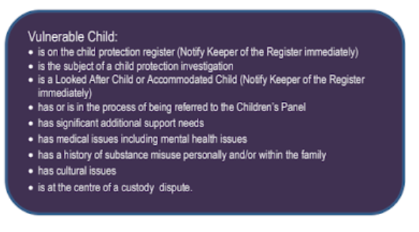

Children missing education: statutory guidance for local authorities (2013) UK Legislation

